DBMS Lab

Ali Zain 21K4653

Task #1:

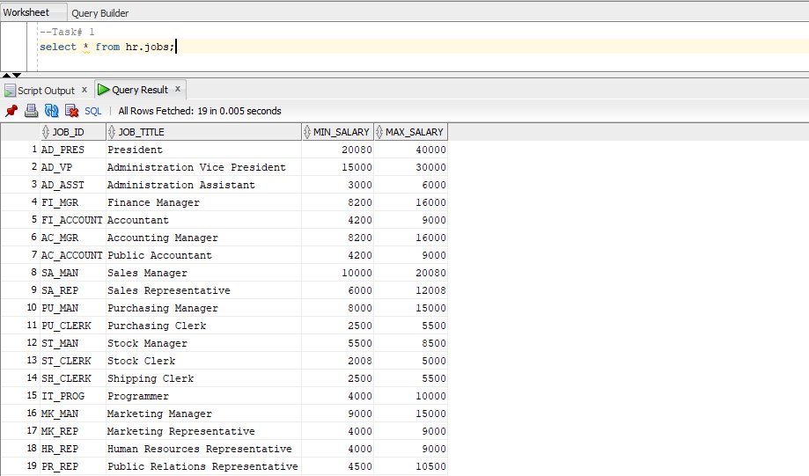

**Task #2:**

**Task #3**

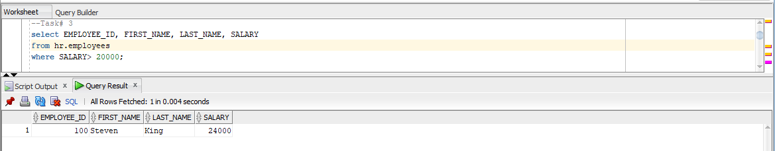

**Task #4**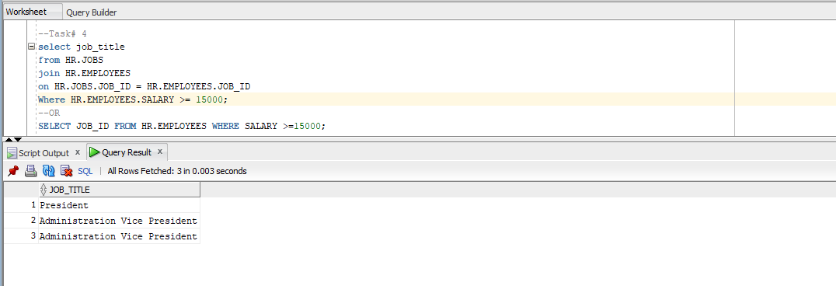

**Task #5**

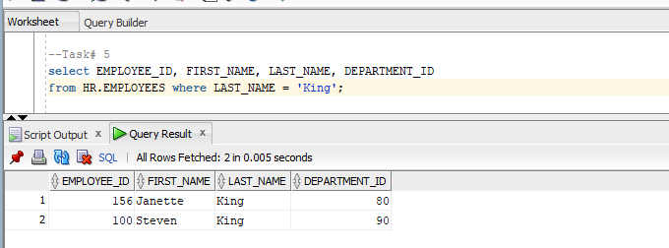

**Task #6**

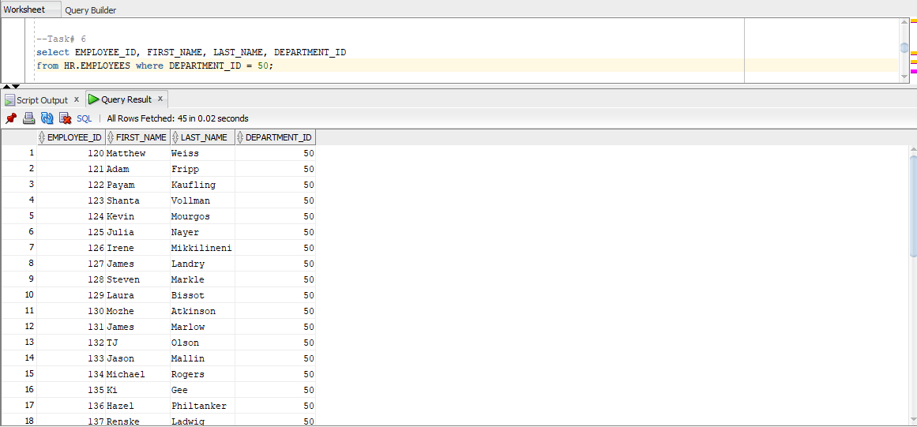

**Task #7**

**Task #8**

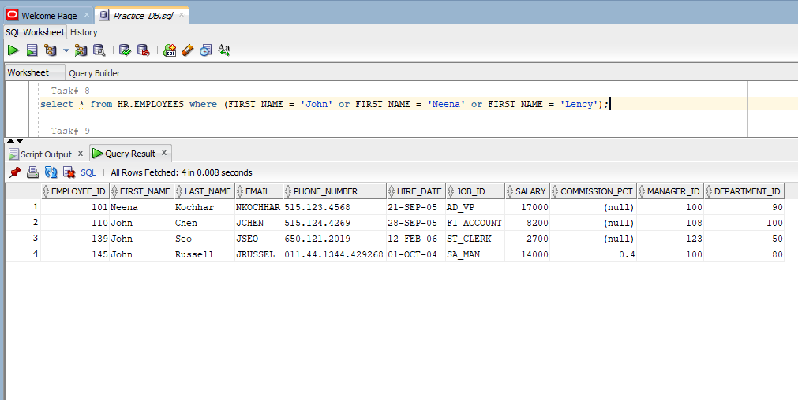

**Task #9**

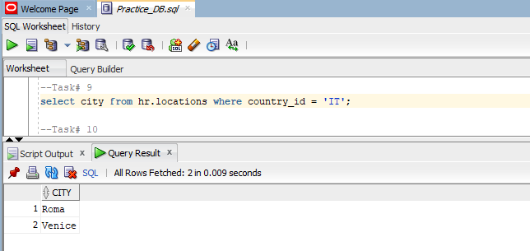

**Task #10**

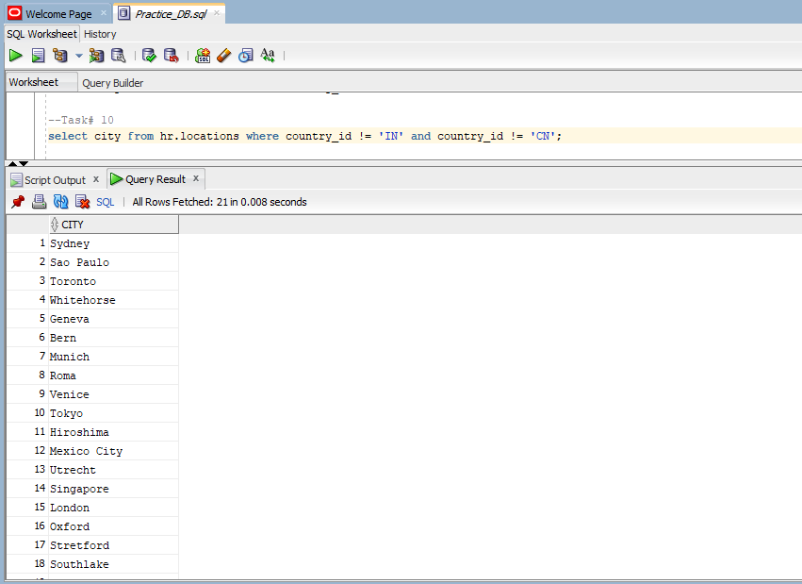

**Task #11**

**Task #12**

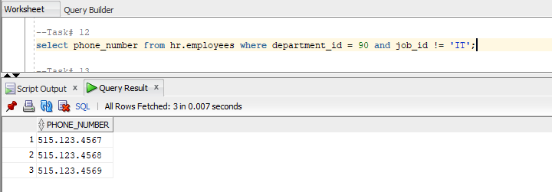

**Task #13**

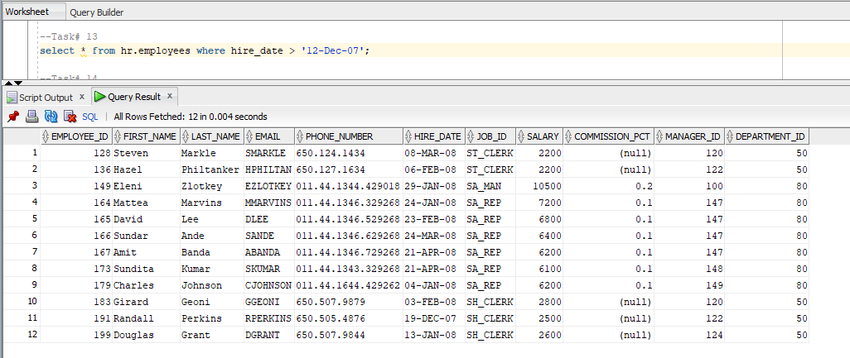

**Task #14**

**Task #15**

